Please use about 14 pt. font for the title,
Times or Times New Roman fonts are recommended.
Please keep
25mm margin.
Please keep
25mm margin.
Author Name ¹ and Author Name ² (12 pt.)
¹ Department of Chemical Engineering, Seikei University¹ (12 pt.)
² Department of Polymer Engineering, Kakou University

This template sheet provides how to write the manuscript for the preprints of the Seikei-Kakou annual/autumnal meeting. A4 paper size and two pages are recommended as the manuscript. All authors should read through the instructions carefully written in below not to make a simple mistake. The organizing committee strongly requests the authors to submit the manuscript before the deadline as PDF file (maximum size: 5MB). 200 words for abstract.
Keywords: Please write 3 - 5 keywords.

Introduction
Recent years, polymer processing --------------------
------ (Extended abstract should be clearly printed for photocopying publication. Main text is single space with 9 or 10 pt., Times or Times New Roman fonts, and the length is two pages.) --------------------

Experimental Setup
-------------------------------------------------------------
--------------------------------------------------------------

Numerical Simulation
-------------------------------------------------------------
---------------------------------------------------------------
$a+b=c$ (1)
---------------------------------------------------------------
Results and Discussion
Authot Name 1* and Author Name 2
*Department of Chemical Engineering, Kakou Univ.
5-8-5, Oosaki, Shinagawa-ku, Tokyo 141-0032
Tel: 03-5436-3822, Fax: 03-3779-9698
E-mail: seikei_tarou@kakou.ac.jp
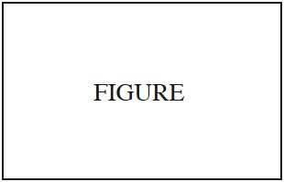
Figure 1 Sample figure

Table 1 Sample table
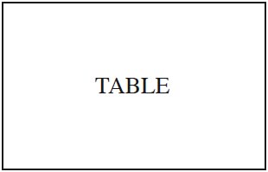

Conclusions
-------------------------------------------------------------
---------------------------------------------------------------
---------------------------------------------------------------
---------------------------------------------------------------

References
1) Tarou Seikei, Jiro Kakou and Sukio Kanagata: Polymer Processing, 1, 10 (2019)
2) Tarou Seikei, Jirou Kakou and Sukio Kanagata: Polymer Engineering and Science, 31, 20 (2010)
Please keep 25mm margin for printed area.
Extended abstract must be two pages.

